LAB 1

Review: Structured Programming and Modules

by

William Schlesner

CS-200

Programming in C++

Prepared for

Professor Andrew Mehri

**Abstract**

In this lab the student will program and design a banking program to add clients, apply transactions, and view balances. The program will have a main menu where the user can create accounts, apply transactions, view balances, and exit the program. The lab has four parts each part building on the next. Major findings in this lab are how much longer it takes to code programs without OOP, even though this was a C++ project. It was still faster to code this program than to use standard C Programming. Another major finding was how header files make it easier to make global functions to use with all your different parts of code.

**Methodology**

Begin the lab by starting your computer and launching your IDE/Compiler either if it be DevC++ or NetBeans. Then following the labs instructions start part one with creating the menu. Then going through each part of the menu to make sure the code works. Work through the options to make the program work properly. Part one should be non-persistent and only work with one client. If anymore clients are added then the one before it will be overwritten. Following part one, part two will be worked on, continuing where part one left off go though and change the program where clients are able to have both savings and checking accounts. Then following part two move to part there where the program will be changed again to accommodate everything from part two plus allowing for multiple clients that are non-persistent. Part four of this program is where you take the code from part three and make the data persistent so the banker can save the file to a text document and be able to retrieve the data when the program is restarted. These parts finally put together to make the program flow and work as a functioning program.

**Results**

**Part 1**

Part one allows the banker to add a user and select whether they have a checking or savings account. With this program there can only be one client.

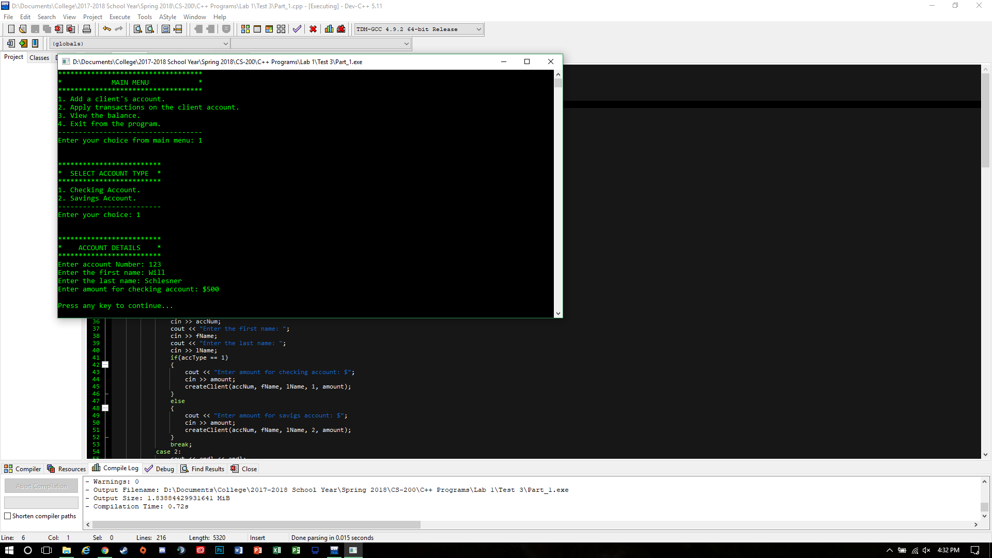

**Part 2**

Par two allows the banker to add one client who can have either a checking, savings, or both accounts. Once a new client is added the old client will be erased.

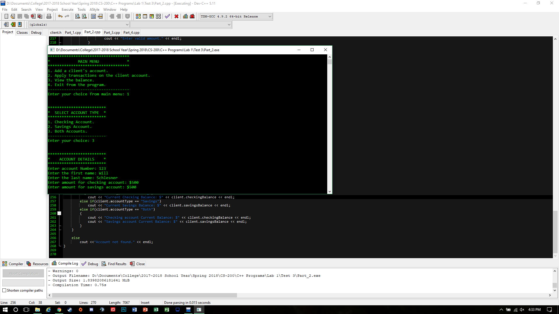

**Part 3**

Part three allows for more than one client with everything for part two. Allowing the banker to search for the clients account by using the account number that was assigned to them during the creation of the account.

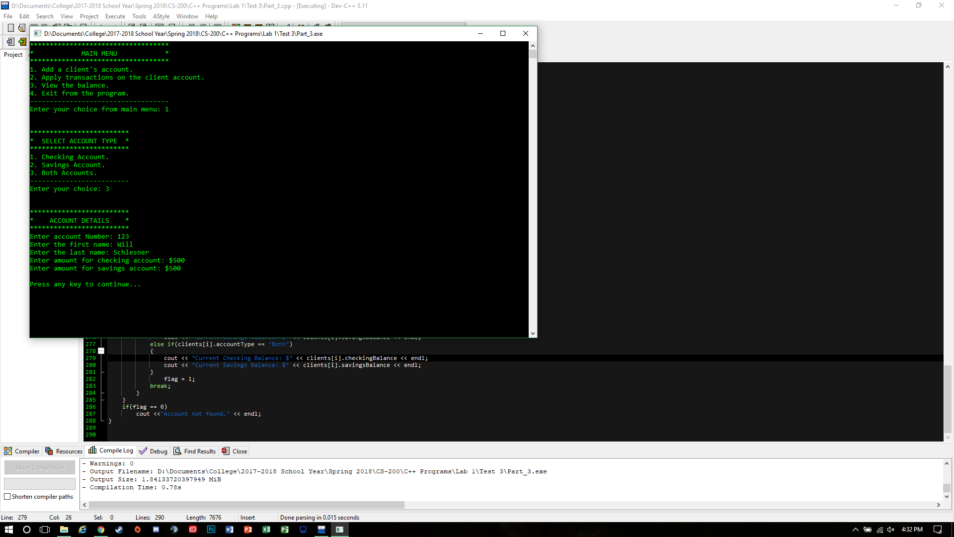

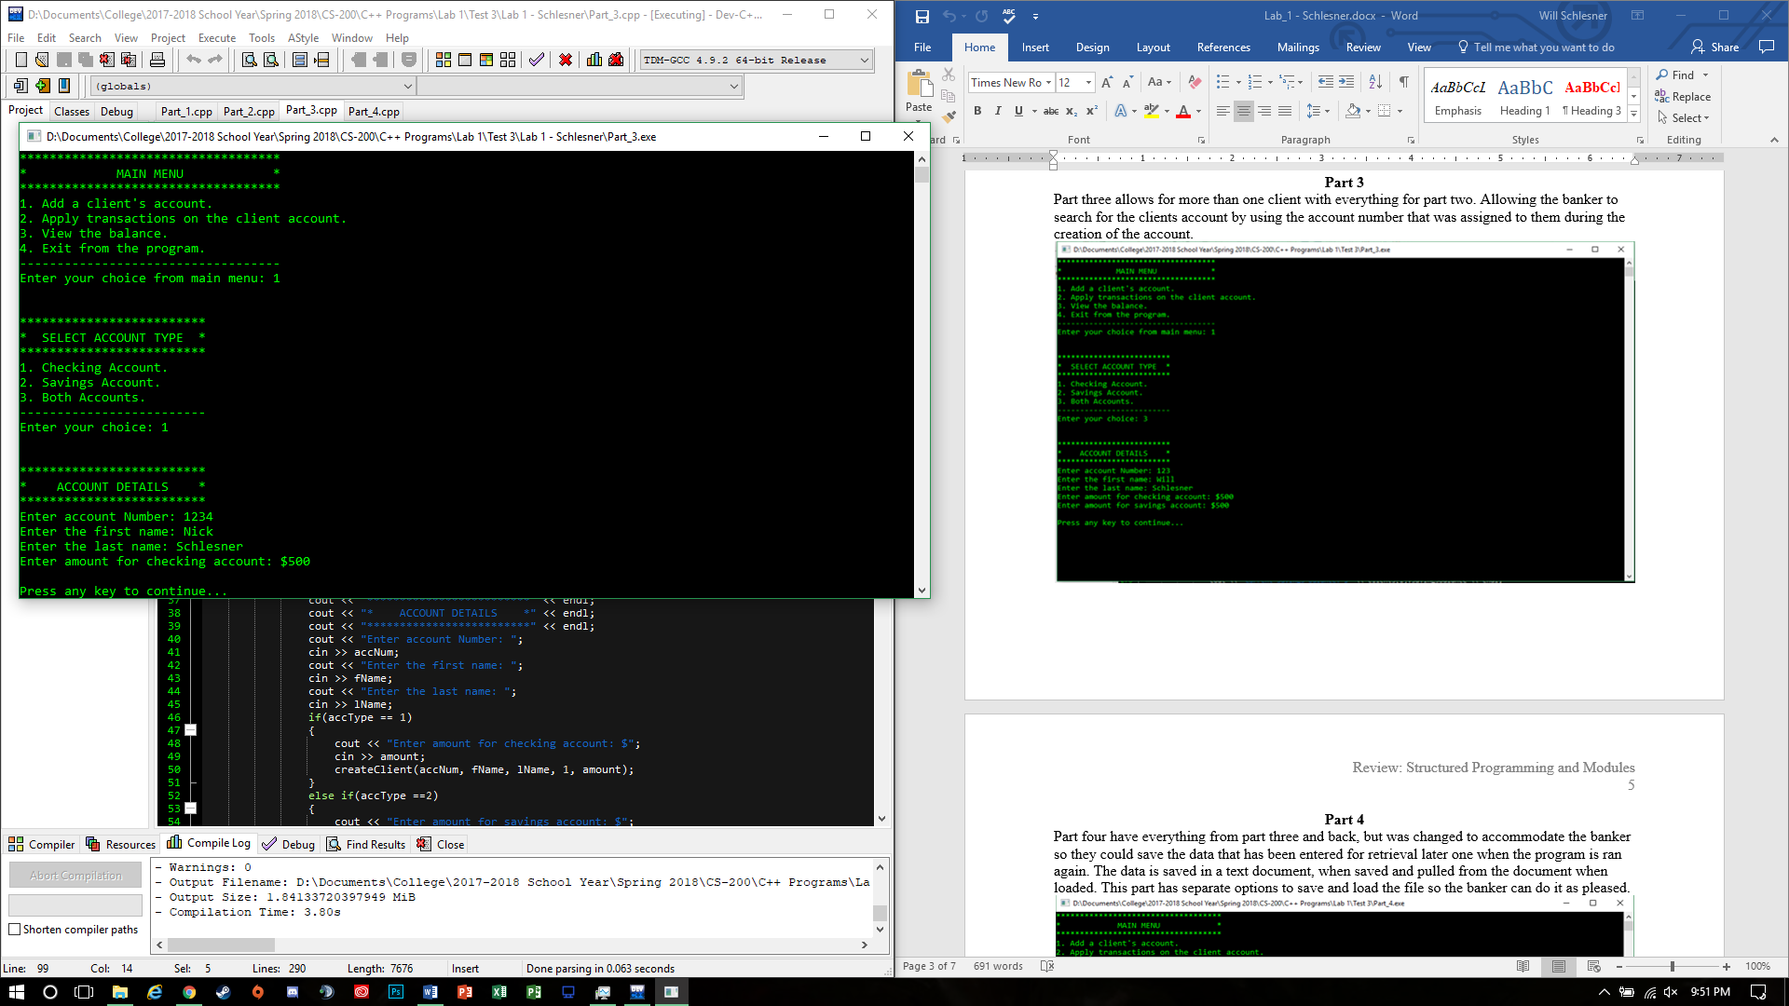

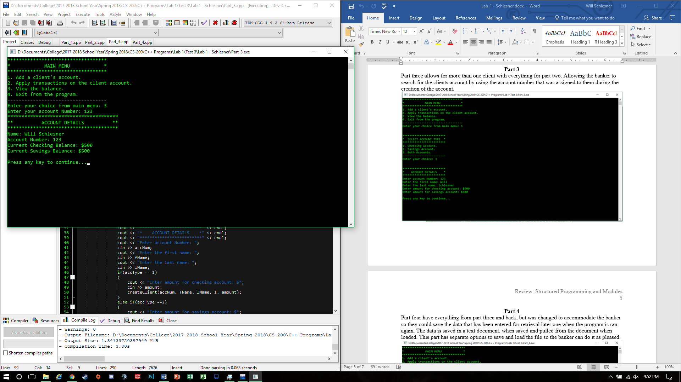

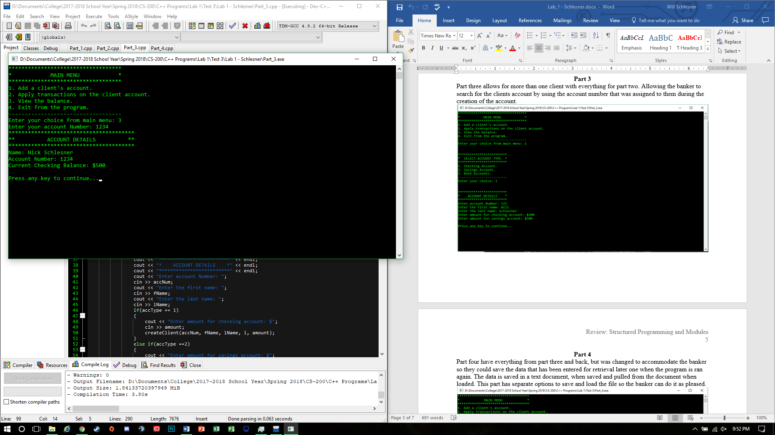

**Part 4**

Part four have everything from part three and back, but was changed to accommodate the banker so they could save the data that has been entered for retrieval later one when the program is ran again. The data is saved in a text document, when saved and pulled from the document when loaded. This part has separate options to save and load the file so the banker can do it as pleased.

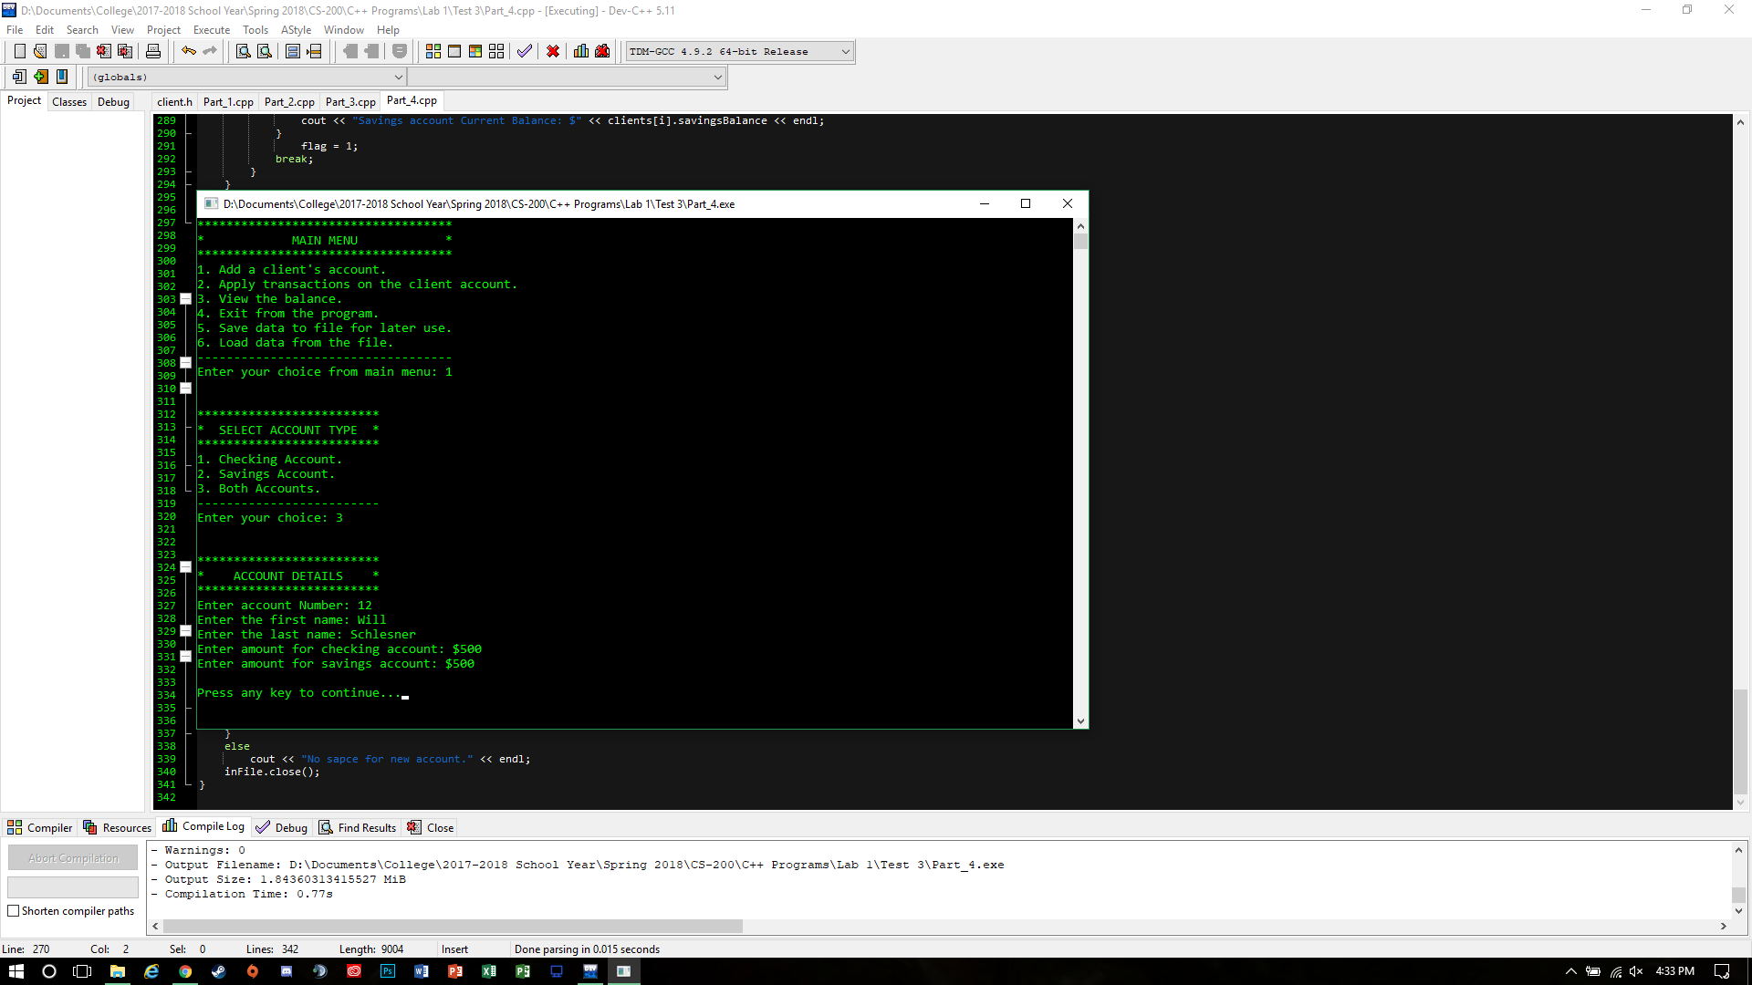

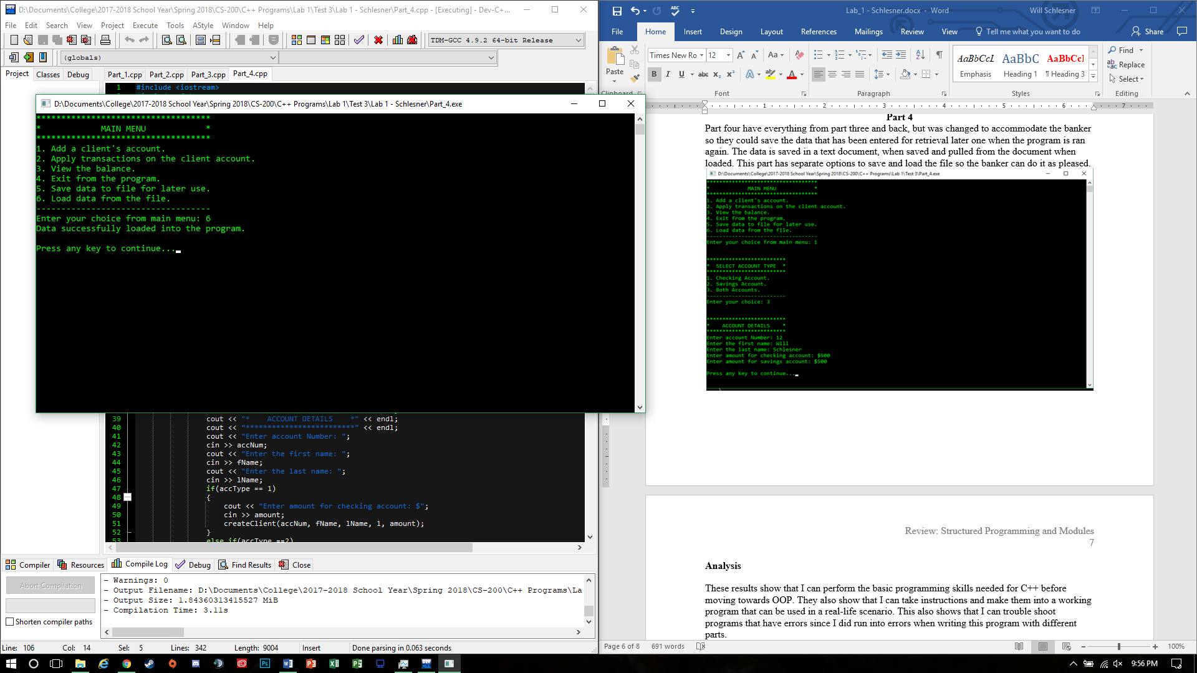

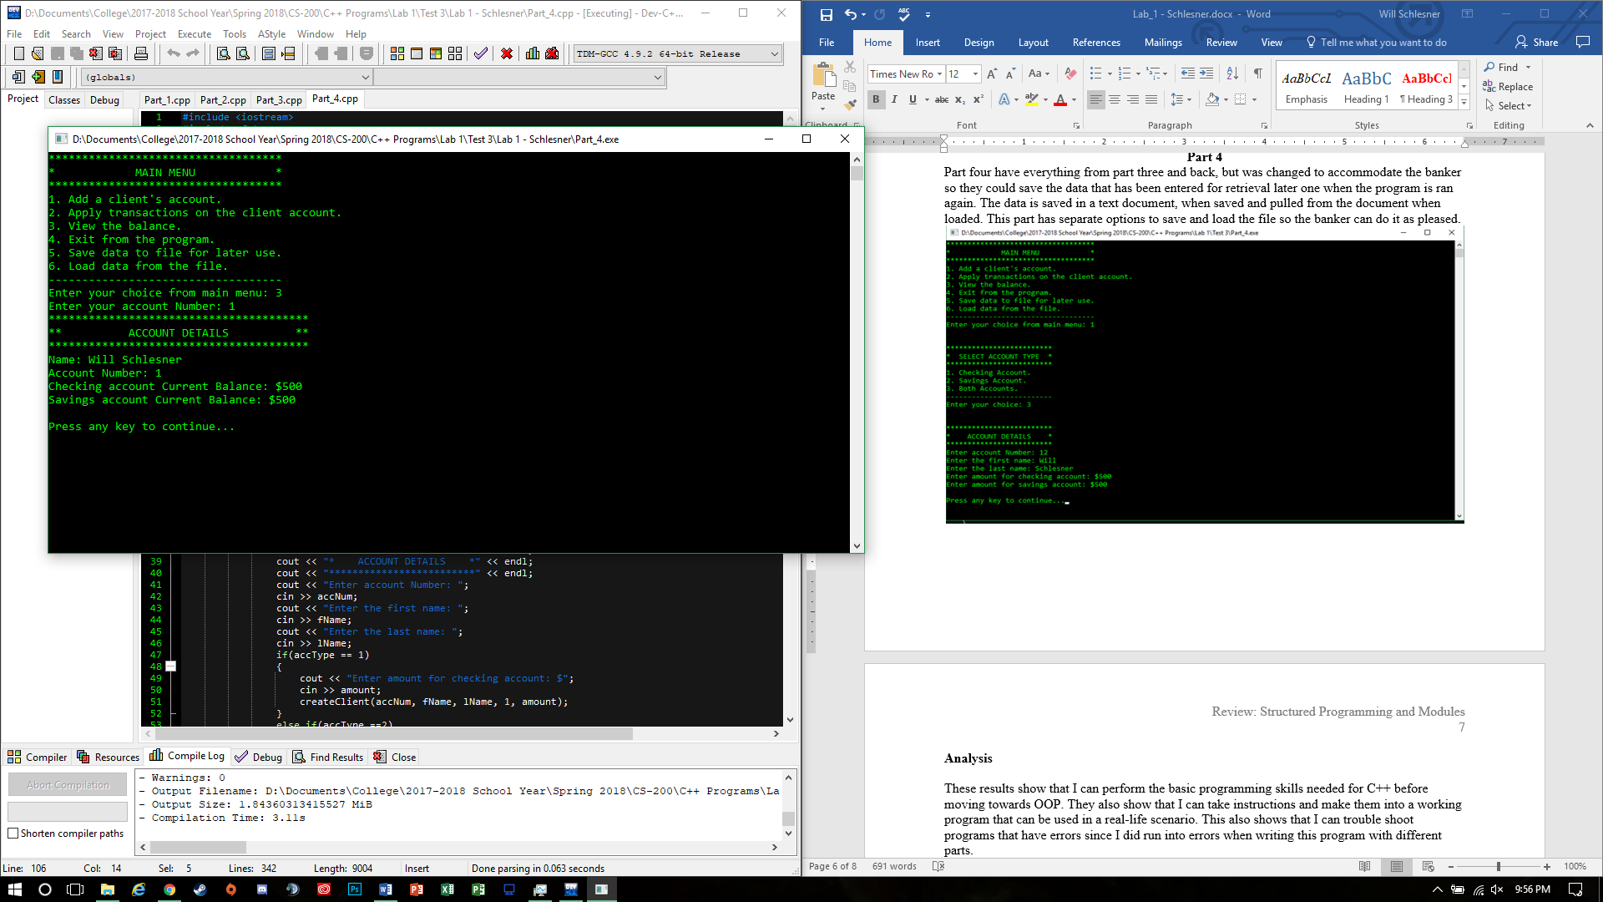

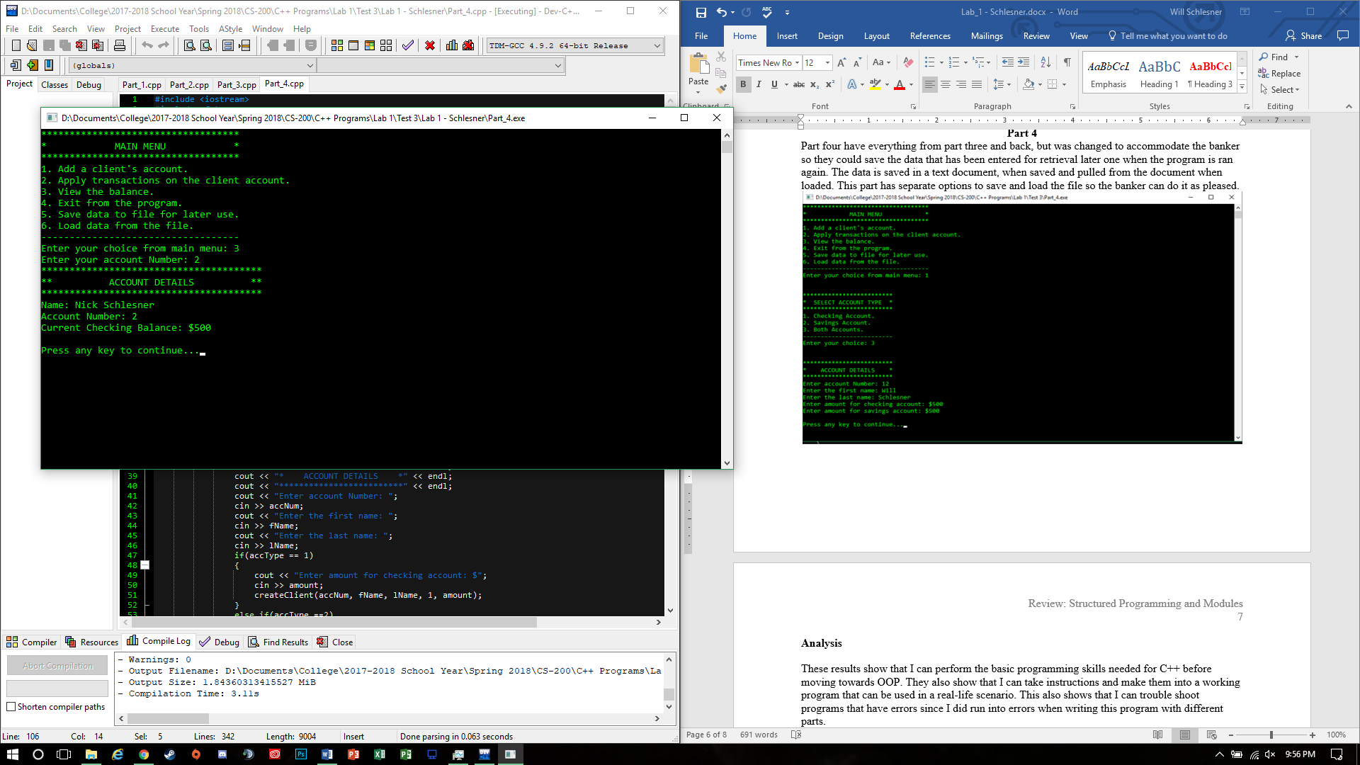

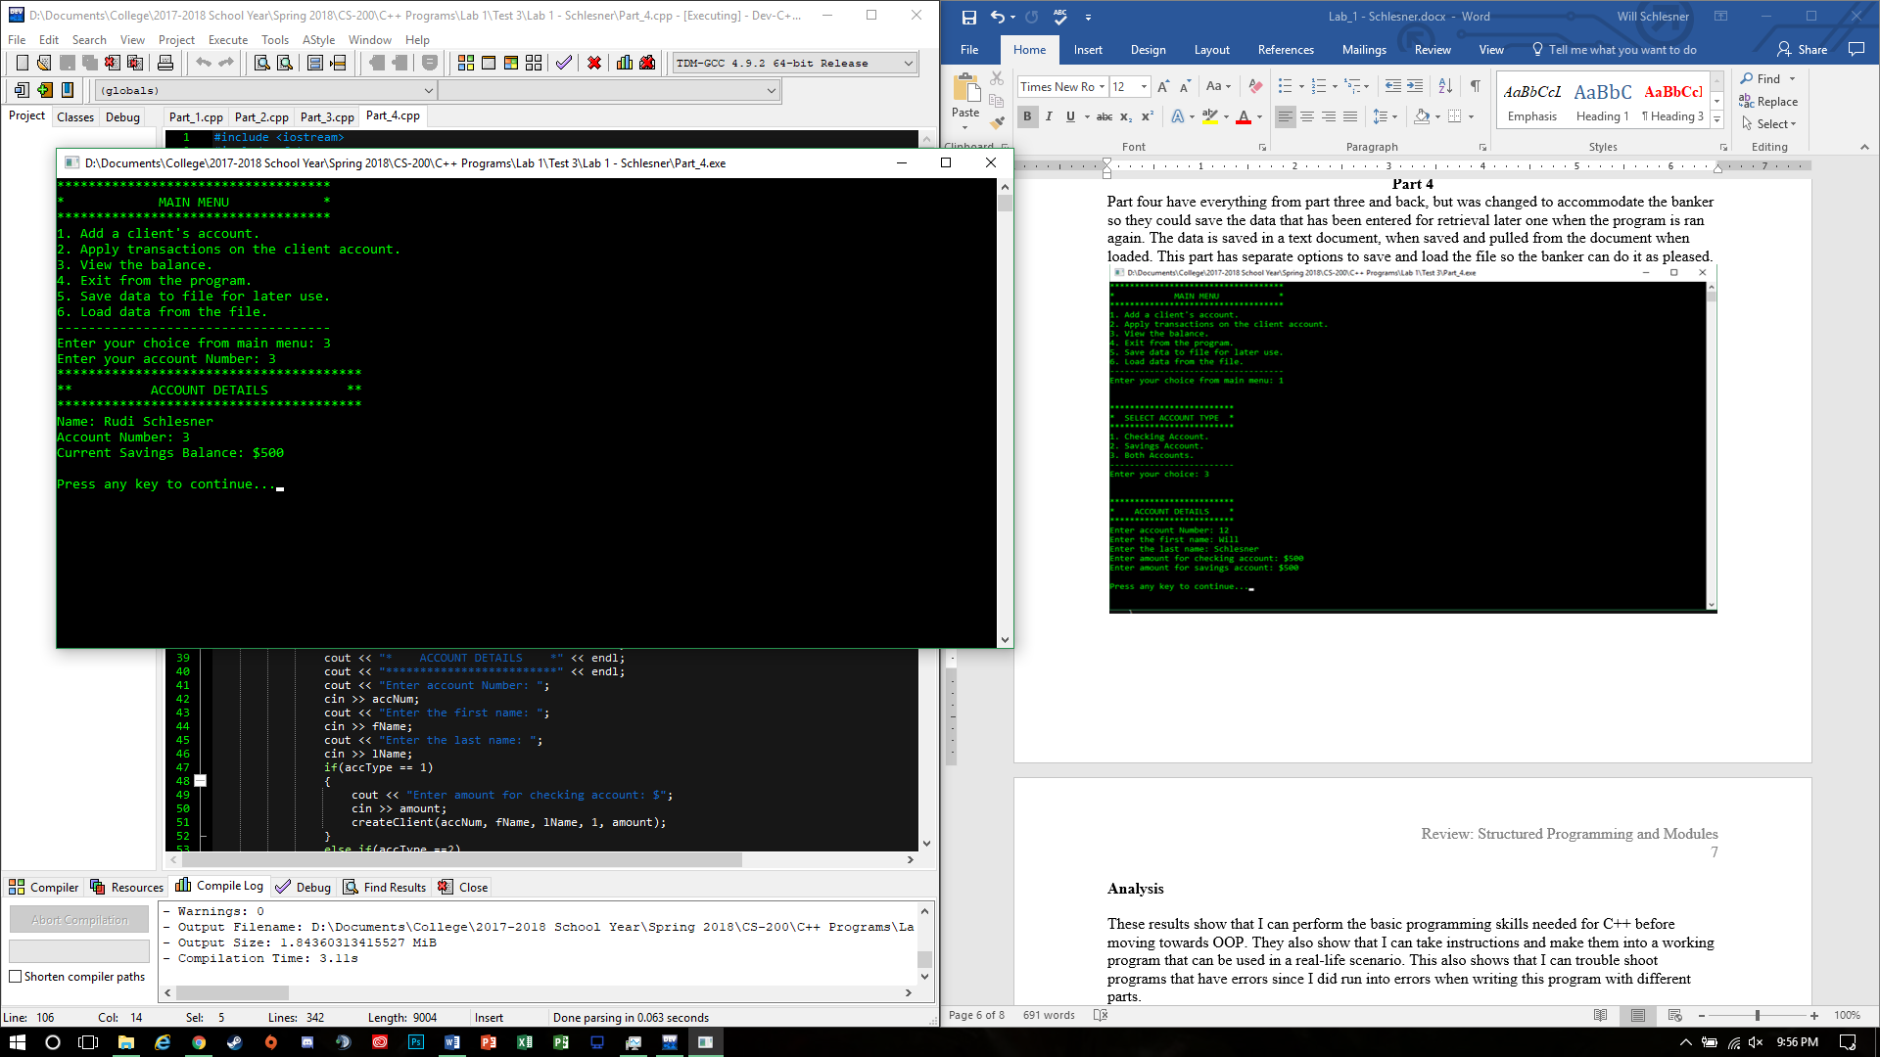

**Analysis**

These results show that I can perform the basic programming skills needed for C++ before moving towards OOP. They also show that I can take instructions and make them into a working program that can be used in a real-life scenario. This also shows that I can trouble shoot programs that have errors since I did run into errors when writing this program with different parts.

**Conclusion**

Overall this project has shown that the aspects of C++ without using OOP concepts. It has also shown how structs and file I/O can be accomplished without using the long process of C programming. This project has given me confidence in creating C++ programs that will work to a high degree. This project has taught me about the little details and how they could affect your program. I learned the different syntax for C++ programming, but overall this project has taught me some of the basics that will be needed for OOP concepts.

**References**

C program to create a file. (2017). Retrieved January 28, 2018, from http://www.includehelp.com/cpp-programs/create-file.aspx

Reference. (2017). Retrieved January 28, 2018, from http://www.cplusplus.com/reference/